**Brooklyn torah gazette**

**For parshas beha’alosecho 5781**

Volume 5, Issue 41 (Whole Number 241) 18 Sivan 5781/ May 29, 2021

**Printed L’illuy nishmas Nechama bas R’ Noach, a”h**

For a free subscription, please forward your request to [***keren18@juno.com***](mailto:keren18@juno.com)

Past emails can be found on the website **ShabbosStories.com**

**NYPD Chief of Dept.**

**Walks Streets of Flatbush**

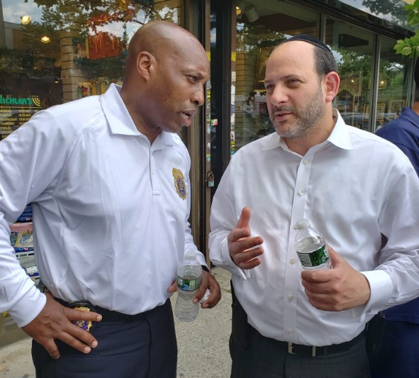

**NYPD Chief of Dept. Rodney Harrison talking to a Jew in Flatbush**

After recent security incidents in New York City in the aftermath of the Gaza war, the Flatbush Shomrim & the Flatbush Jewish Community Council coordinated with the New York Police Department (NYPD) to deploy officers at strategic locations in the Flatbush community, including at Yeshiva dismissals. Police were visible all over the community, as resources were brought in from other parts of the city. Yeshiva World News was inundated with reports of police cars at Yeshivas around the area during dismissal, as officers stood by to ensure the safety of the tens of thousands of Yeshiva children.

On Sunday afternoon, May 23rd, NYPD Chief of Department Rodney Harrison joined a press conference in Boro Park led by NYC Mayor DeBlasio to denounce the string of hate crimes, which came on the heels of a high-level meeting on Friday with the Mayor and Agudath Israel of America at City Hall.

Following that press conference, Chief Harrison personally visited the Jewish communities of Flatbush and Boro Park to hear first-hand concerns of local store owners and residents. The Chief was joined by Deputy Inspector Richie Taylor of Community Affairs, and Pinny Ringel of the Mayor’s Office.

The Chief first went to Pizza Time on Avenue J and East 14th Street, where he was greeted by a group of Flatbush Shomrim volunteers who have been patrolling 24 hours a day to assist the NYPD in keeping the community safe. Josh Mehlman Chairman of the FJCC relayed the deep concerns and fears of the Flatbush community to the Chief.

After a few slices of kosher pizza, the Chief walked up Avenue J to Coney Island Avenue, where he stopped into the “Table And Tennis” game room to play some ping-pong and shoot some hoops with local Yeshiva boys.

He also visited Essen Deli, as well as Eichlers Judaica on Coney Island Avenue, stopping to talk with local residents – some for 15 minutes each.

The Chief showed genuine concern about the issues presented to him, and pledged to work harder to bridge gaps between other nationalities and religious groups in the area and to increase the police presence.

Additionally, the Chief met with Jack Rothenberg, a Flatbush Hatzolah Coordinator, and flagged down a passing Flatbush Hatzolah Ambulance to thank them for their dedication to saving lives.

“Walking the streets of Flatbush and Boro Park today, hearing directly from concerned community members, I understand their fears and I will do everything in my power to help ease the anxiety and bring calmness to the communities, the Chief told YWN.

“I have ordered a full deployment of police officers because our responsibility is not only to keep people safe but also to make people feel safe.”

The FJCC’s Chairman expressed the community’s deep thanks to NYPD Brooklyn South Borough commanders, Deputy Inspector Richie Taylor, Commanding Officer Community Affairs, Lt. Yitzy Jablon Commander of PBBS Community affairs, the 61, 63, 66 and 70 Police Precinct commanders; Flatbush Shomrim; and in particular NYPD liaison Yehuda Eckstein for spearheading todays effort.

Chaskel Bennett FJCC Co- founder added, “all of our community partner organizations have been working together to secure our neighborhoods. We cannot let up. There are very serious security issues we are grappling with and we need our partners at the NYPD to do what they do best in order to keep us safe.”

Flatbush Shomrim Executive Coordinator Bob Moskovitz spoke to YWN and had nothing but words of praise for today’s visit.

“I don’t remember a time when the highest-ranking uniformed member of the NYPD spent this much time in the community (nearly three hours!) walking around talking to regular pedestrians and hearing their issues,” Moskovitz said.

“The Chief really showed compassion and listened to people, many of whom are the children of Holocaust survivors. The overwhelming response by the NYPD today by deploying extra coverage in the area is something to commend the Chief on.

“The Chief listened to our issues that we encounter while patrolling the streets late at night, and thanked our volunteers profusely for their dedication,” Moskovitz added.

The Chief told YWN that people should remain vigilant and call the police if they see anything suspicious. Don’t wait until it’s too late! See something, say something!

*Reprinted from the May 23, 2021 website of Yeshiva World.*

# Rav Avigdor Miller on

# Post Shavuos Avodas Hashem

**QUESTION:** **Now that we finished counting the Omer and we had Shavuos and we already received the Torah, so what should be the focus of our service of Hashem from after Shavuos until Rosh Hashana?**

ANSWER: Now rabosai, I’m going to tell you something that I always say: The happiest season of the year is the summertime; yes, the good old summertime. And so, let’s learn to enjoy life right now. There’s nothing like summertime. In the summertime if you’re a landlord, you don’t spend any money on heating the building. Think of all the money you save in the oil bills! That’s a happiness. You think it’s silly? It’s not silly at all.

Summertime, there are no colds! Unless you sit in front of the air conditioner all the time and you drink only cold drinks – watch out for that! But otherwise, you won’t catch a cold. Respiratory illnesses? Not in the summertime! No coughing, no sneezing! The summertime is a pleasure! What a great blessing it is!

In the summertime you get vitamins free of charge. Walk out in the street and the sun is showering vitamins on you; the sun is a vitamin dispensary. In wintertime there are clouds and you don’t always get the vitamins you need. Sometimes you have to take extra vitamin pills. In the summertime, you get all you want.  And so, boruch Hashem for the summertime.



In the summertime fruits are plentiful. That’s when the apples are coming. Ah! Red apples and luscious cherries and plums and peaches; they’re plentiful in the summer and the prices go down in all the fruit stores. Now you’re living!

Look how much there is to enjoy in the summertime. When you walk out in the street, don’t complain, “Oh, it’s a hot day.” Don’t be a fool! Hakodosh Boruch Hu is giving you so much energy from the sun and it’s free of charge. Millions of tons of horsepower energy are pouring onto this earth free of charge in the summertime; it’s causing the earth to become enriched and the fruits to develop.

And it doesn’t cost you a penny to get all that energy from the sun.  So when you walk out into the street you have to say, “Boruch atah Hashem yotzer ha’meoros.” Don’t say Hashem’s name of course. But something you must say! You have to thank Hashem for the summertime.

So, this person asks: What’s the service of Hashem from Shavuos until Rosh Hashanah, Yom Kippur? The service is singing to Hashem. Learn how to sing to Hashem. And don’t think it’s a small thing. Tov lehodos laHashem – Do you know what’s good in this world?  To sing to Hashem and to thank Him.  That’s what’s good. It’s the only good there is.

What do you think was the avodas Hashem that we were mekabel when we accepted the Torah on Har Sinai? The most important service of Hashem is gratitude to Hashem! So now you know that from Shavuous until Rosh Hashanah we’re busy singing and thanking Hashem for the manifold benefits He’s giving to us; and we’ll never do it enough. We’ll never thank You enough!

That’s the very great service in the summertime.  It doesn’t mean you have to stop learning. We can continue learning and doing Torah and mitzvos. Nevertheless, the avodah of gratitude for the summertime, the happiness of the summertime and thankfulness for the summertime is a very important avodah to be busy with. TAPE # 743

*Reprinted from the May 19, 2021 email of Toras Avigdor. Adapted from Tape #743.*

**Parshas Ba’Halosecha**

**Why We Hate the Jews**

**By Rabbi Bentzion Shafier**

**Founder of TheSmuz.com**

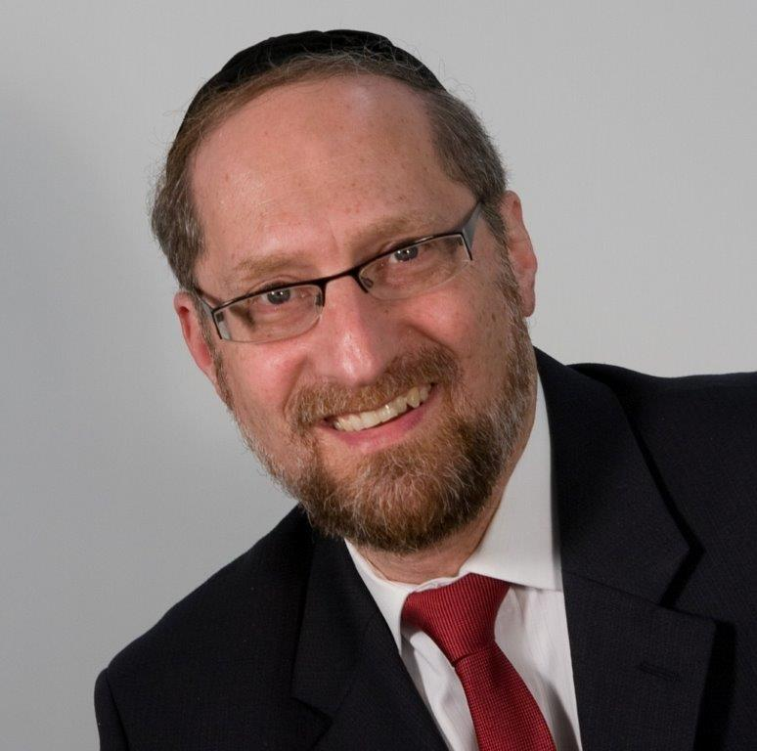

“When the Holy Ark would travel, Moshe would say, `Arise HASHEM, and let Your foes be scattered. Let those that hate You flee from before You.’” — Bamidbar 10:35

In this posuk, Moshe Rabbeinu is equating hatred of the Jews with hatred of HASHEM. “Let those that hate **You** flee from before You.”

Rashi is bothered by the comparison. Why does Moshe’s call the enemies of the Jews, “enemies **of HASHEM**?” Maybe they are just enemies of the Jewish people? Rashi answers, “**Anyone who hates Yisroel hates HASHEM**.” It seems clear that Rashi assumes that the root cause of anti-Semitism is hatred of G-d.

This concept of attributing hatred of **Jews** to hatred of **HASHEM** seems difficult to understand. After all, if we study history, we see many reasons that Jews were hated – and they had nothing to do with hating HASHEM.

**The Jealousy Theory**

One reason that has been commonly cited for anti-Semitism is simply **jealousy**. Historically, it was the Jew who brought his economic wisdom and acumen to the various countries he inhabited; it was the Jew who became the adviser and confidante to kings and governors. The Jewish contribution to the cultural, scientific, and technological evolution of civilization is nothing short of astounding. Whether in academics, politics, the media, or the professions — from curing polio to discovering atomic energy, from Hollywood to Wall Street — Jews have had an extraordinary influence on human progress.

It seems that in business, politics, art, theatre, science, and social movements, the Jews are at the head. With contributions as diverse as those made by Freud, Spinoza, Trotsky, Kafka, Jerry Seinfeld, and Albert Einstein, the Jew excels. From 1901 till 1990, over 22% of Nobel prizewinners worldwide were Jewish, even though Jews constitute less than ¼ of 1% of the world’s population.

This alone would seem like a logical reason for anti-Semitism. The Jews have proven to be smarter, more enduring, and more successful than the peoples of the lands into which they were exiled.

However, this isn’t the only reason. There are many more.

**The Scapegoat Theory**

Another cause held responsible for anti-Semitism is the **scapegoat theory**. To gain power or distract the population from their suffering, a monarch would look for a place to put the blame. What better a place than the eternally despised Jew? By arousing the masses to Jew-hatred, an individual seeking power could use this energy as a galvanizing force to bring together masses of unaffiliated individuals. We certainly have seen many instances of this during the past 2,000 years.

**The “We Killed Their god” Theory**

But there are other reasons that sound plausible. One is **deicide** – we killed their god. The average person would agree that is a sound reason to hate a people. After all, it certainly doesn’t sound very friendly, charitable, and kindly to kill god.

**The Chosen Nation Theory**

Finally, one of the most oft-quoted reasons to hate the Jews is that we make no secret of the fact that we are the Chosen People. As clearly written in the Torah, the Jewish people have been given a unique role to play amongst the nations: to be a light, a guide, and HASHEM’s most beloved nation. Is it any wonder that throughout the millennium we have been hated?

But these aren’t the only reasons. There are many, many reasons presented to hate the Jews. How does Rashi explain that **anyone who hates Jews, hates HASHEM**? Maybe it is simply one of the reasons above.

**The Answer – There is No Answer**

The answer to this question seems to come from the very question itself: why is it that the one constant throughout history is that everyone always hates the Jews? It seems that all things change. Movements come and go; ideologies pass with time; systems of governments evolve. The only thing that doesn’t change is that everyone hates the Jews. Rich or poor, powerful or weak, dominant or oppressed, the Jew is hated – and then blamed for causing that very hatred.

Beginning with Avraham Avinu almost 4,000 years ago, there has been an endless stream of reasons to hate the Jew. And that itself is a most curious phenomenon. In whatever country the Jews found themselves, they were loyal and industrious citizens, yet they were always hated and always for different reasons.

Despised in one county for being too powerful, then trampled in another land for being too weak. . . Segregated into ghettos, then accused of being separatists. . . Accused by capitalists of being communist, hounded by communists because they were “all” capitalists. . . Hated for killing a religion’s god, yet equally despised in civilizations that don’t worship that god. . . Called “children of the devil” and the devil himself. . . Blamed for the Bubonic Plague and typhus, for poisoning wells and using sacrificial blood for baking matzahs. . .

With such varied and assorted rationales, it seems that there is no shortage of creativity when it comes to hating the Jew. The only consistency in reasoning is: we hate the Jews. Why we hate them doesn’t matter. The cause of the hatred doesn’t matter. The only thing that really matters is that we truly, truly hate them.

What Rashi is teaching us is that there is no plausible reason for anti-Semitism. It can’t be explained because it makes no sense. When you look into every cause, not only doesn’t it answer the question as to why, you quickly find another circumstance where that cause wasn’t present, yet the hatred was still there – as powerful and pervasive as ever.

**The Jew Represents HASHEM**

The pattern that emerges is that there is no logical reason for anti-Semitism until you focus on the real cause – that the Jew represents HASHEM. We are HASHEM’s people. When the gentile looks at a Jew, he sees HASHEM, and that image is not always attractive to him.

This concept carries a huge lesson for us. While we may forget our holiness and our destiny, the gentile nations are always there to remind us: we are different, we are unique, and our role is unlike that of any nation. As is quoted in the name of Rav Chaim Volozhin, “If the Jew doesn’t make kiddush, the goy will make havdalah.”

If we recognize our greatness and live up to our title of the Chosen People, we are then exalted, revered and respected. When we fail to recognize our unique destiny and absorb the cultures of the times, then we are sent reminder after reminder of our unique role amongst the nations – HASHEM’s Chosen People.

*Reprinted from the website of Theshmuz.com.*

**Rabbi Berel Wein on**

**Parashat Behalotcha 5781**

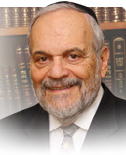

We are familiar with the Rashi’s comment in the second verse of this week's Torah reading that the Priest who lit the candelabra was to keep the fire close to the wick, until the wick itself caught fire and rose by itself. This is a lesson not only regarding the lighting of the great candelabra in the Temple but is also a metaphor for many life situations. Unless the wick itself truly catches fire and holds the flame on its own, the effort expended in attempting to light this wick will ultimately be fruitless and unsuccessful.

This metaphor is true in family life as well, for if our children and grandchildren are unable to be successful on their own, then the parents have somehow failed their responsibility regarding their children. This is also true in the realm of education. Students who can never be productive on their own, no matter how much knowledge they have, will not be a source of pride to their teachers.

We have witnessed many times in life that people who were somehow voted to be the most likely from their class to be successful in the future, do not fulfill that hope and expectation. Their flame did not kindle itself and is of limited illumination and value. There are many factors that go into this eternal problem of generations of students. However, the result is what usually counts, and everyone agrees that success is measured by the ability to eventually achieve by one's own efforts.

This week's Torah reading itself provides an example of this idea, of making certain that the flame will take hold on its own and not flicker and later disappear. We are taught that the Jewish people undertook what should have been a short march from the mountain of Sinai to enter the land of Israel. They are seemingly well mobilized for the journey and embark upon it with apparent enthusiasm. Nevertheless, this journey turns into a trek of 38 years of bitterness, hostility, rebellion, and eventual demise of that entire generation. Simply put, the flame that was with the Jewish people at the Exodus from Egypt and the revelation at Mount Sinai did not hold fast enough to be able to survive the tests and vicissitudes of life and the events that lay ahead.

It would be the task of the later generations to summon the will and tenacity necessary to see to it that the tools necessary for the national growth and development of the Jewish people in the land of Israel would be strong enough to maintain itself on its own. That remains the challenge in Jewish life throughout the long centuries of our existence, and especially over the tumultuous centuries that we have recently experienced. Tenacity of purpose and strength of will have been and remain the key weapons in our arsenal of survival and triumph, and we will see the flame of Israel strengthen and rise once again in our days.

*Reprinted from this week’s website or rabbiwein.com*

**The Difference Between Building Pyramids as Slaves and Constructing the Sanctuary**

**From the Talks of the Lubavitcher Rebbe**

**Rabbi Menachem Mendel Schneerson, Zt”l**

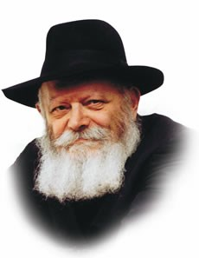

In order to understand the concept of "spreading the wellsprings [of Torah] outward," we need to examine the physical properties of a well.

A well's water gushes spontaneously from its source without waiting for the thirsty person to come and drink. Likewise, its waters flow far and wide, saturating everything with which they come in contact.

In a similar vein, when the objective is bringing the waters of Torah to other Jews, we cannot wait until they come and ask to drink its knowledge. The Torah, the sustenance of life itself, must be brought to wherever Jews are found.

This approach originated with Aaron the High Priest, who "loved peace and pursued peace, loved his fellow creatures and brought them nearer to Torah." Aaron did not wait until others took the first step, but went "outside" to draw them closer to Judaism.

**Never Altering or Compromising the Torah**

Significantly, Aaron "brought them nearer to Torah," and not the other way around. The Torah's principles were never altered or compromised to fit a given situation. Rather, each individual Jew was brought to the Torah, the same true and eternal Torah that has stood immutable for thousands of years.

This characteristic service of Aaron is alluded to in this week's Torah portion, Beha'alosecha -- literally, "When you light the lamps."

As High Priest, Aaron's job entailed kindling the menora in the Sanctuary.

A candle is symbolic of the Jewish soul, as it states, "the candle of G-d is the soul of man." Aaron's function was to light the candle, i.e., ignite the soul of every Jew, for every Jew possesses a G-dly soul, no matter how concealed it may be. By lighting this "candle," Aaron revealed the flame that burns inside each and every one of us.

**The Aroused Jewish Soul**

Furthermore, Aaron made sure that the candle would continue to burn without his assistance. It is not enough to uncover the G-dly soul that exists in the recesses of every Jewish heart; the soul must be so aroused that it continues to burn with love of G-d and perpetually seeks to reunite with its Source Above.

Thus, "spreading the wellsprings outward" requires that we go "outside," beyond our own "space" to awaken the hidden spark of G-d that is the birthright of every Jew. For no matter how hidden it may seem to be, all that is necessary is that we find it and fan its flame until, like a candle after the match which lit it has been removed, it continues to burn by itself.

*Reprinted from the 5756/1996 Parshat Nasso edition of L’Chaim Weekly. Adapted from Likurwi Sichot Rebbe, Vol.2.*

**Stories of Two Famous Celebrities Who Became Torah Observant Jews**

**By Daniel Keren**

(Meaningfulpeoplepodcast – “From Israel Film to Bnei Berak Gadol – Rabbi Uri Zohar” (52:17)

(Meaningfulpeoplepodcast – “From the NBA to Judaism: The Story of Amar’e Stoudemire” (1:13:22)

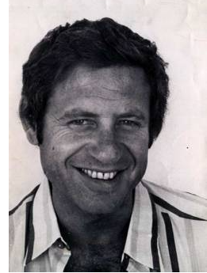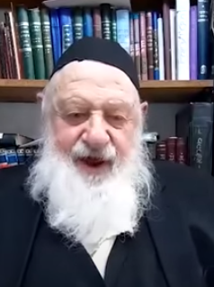

**Rabbi Uri Zohar (before and today)**

One of the most popular Jewish podcasts is the Meaningful People podcast, which for the past year under the direction of the two cohosts – Yaakov Langer and Nachi Gordon has interviewed Jewish men and women in the Orthodox community whom the hosts consider to be “meaningful people.” For more information about this podcast you can google meaningfulpeoplepodcast.

Among the dozens of meaningful people personalities highlighted in the past year are a couple of famous celebrities who were inspired to trade their glitzy lives and become religious Orthodox Jews.

If you are Israeli you certainly know who Uri Zohar was and is. He is perhaps the most famous Israeli baal teshuva (secular Jew who made the decision to become Torah observant.) Prior to making the decision to become Orthodox, he was perhaps the most popular comedian, actor and cinematic director in Israel. To understand the significance of Uri Zohar’s cultural importance is to compare him to Woody Allen in the United States. At the time he became religious, Uri Zohar lived in the largest and fanciest house in all of Israel.

Unlike most of the tens of thousands of Jewish men and women (baalei teshuvah) around the world, Uri Zohar didn’t decide to continue his career as a religious Jew. Born in late 1935 in Tel Aviv, Uri was 40 years old when he “reluctantly” made the decision to become frum.

Uri Zohar told Yaakov Langer and Nachi Gordon that after being persuaded by Rabbi Yitzhak Shlomo Zilberman of blessed memory that G-d does exist and that He gave the Torah to the Jewish people and that we Jews are obligated to be religious, he asked Rabbi Zilberman what was the absolute minimum he was required to keep in order to get a back row seat in Gan Eden.

And from that absolute minimum, Uri Zohar began studying Torah. And that was the turning point in his life. He felt a growing excitement towards learning Torah and everything else including his successful entertainment career seemed irrelevant. He quickly abandoned his career and spent the next ten years learning Torah and eventually become Rabbi Uri Zohar

In his meaningfulpeoplepodcast interview, Uri Zohar admitted that his sudden decision to become religious, did not go well with his wife who was not willing to cooperate. He realized that they were going to have to get divorced. Miraculously at that time, he returned home shortly before the planned divorce and found his wife reading a sefer by the Rambam. She told her husband that she didn’t understand everything in the sefer but she understood that Torah Judaism was deep and important and she was willing to do the minimum – keeping Shabbos, eating kosher and practicing family purity. Since then, Rabbi Zohar confesses she has become even more spiritual than him.

For the last 35 years under the auspices of Lev L’Achim, when not studying Torah almost fulltime in a now very small modest one-room Jerusalem dirah (apartment) Rabbi Uri Zohar has spoken to many thousands of Israelis and has been instrumental in convincing large numbers of his countrymen to become more observant in their own lives.

Another famous celebrity whose story of how he decided to join the Jewish people by becoming a gair (convert) is the Florida-born African American basketball player Amar’e Stoudemire [born in 1982] who starred in both the National Basketball Association and in Israel. A former NBA Rookie of the Year with six appearances in the NBA All Star Game, Amar’e also won the Most Valuable Player honors in the 2020 Israel Basketball Premier League Finals for Hapoel Jerusalem, a major Israeli team that he also happens to be a major owner of.

In his meaningfulpeoplepodcast, Amar’e tells of the long spiritual journey of his that led to his conversion by an Israel beis din (rabbinical court) where he took the Jewish name Yahoshafat ben Avraham.

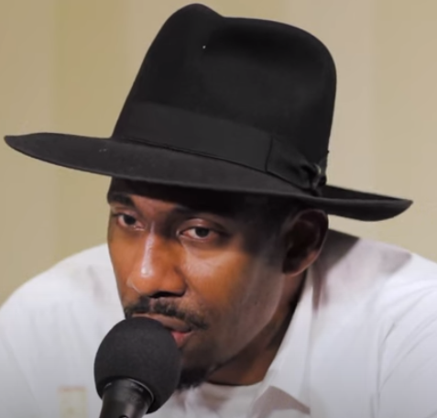

**Amar’e Stoudemire**

More than half of the podcast included questions from Yaakov Langer and Nachi Gordon about his professional basketball career and how it was affected by his growing fascination for Judaism.

One of the points Amar’e/Yahoshafat made in the interview was the importance for him and all Jewish men to guard your eyes. The struggle is to master social media and not let the social media master you.

When asked what he would like to be remembered for, Amar’e declared that he considers it important to continue learning about Judaism and that his goal is to become someone looking to become a part of the Kingdom of Heaven like the Patriarchs (Avraham, Yitzchak, and Yaakov) that basically set the tone for our Yiddishkeit.

*Reprinted from this week’s edition of The Jewish Connection.*